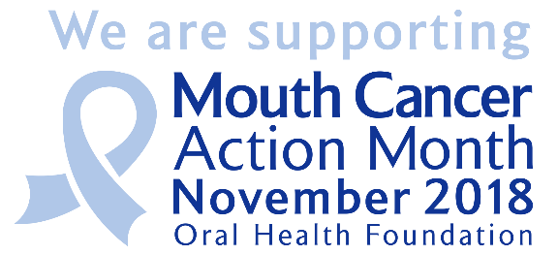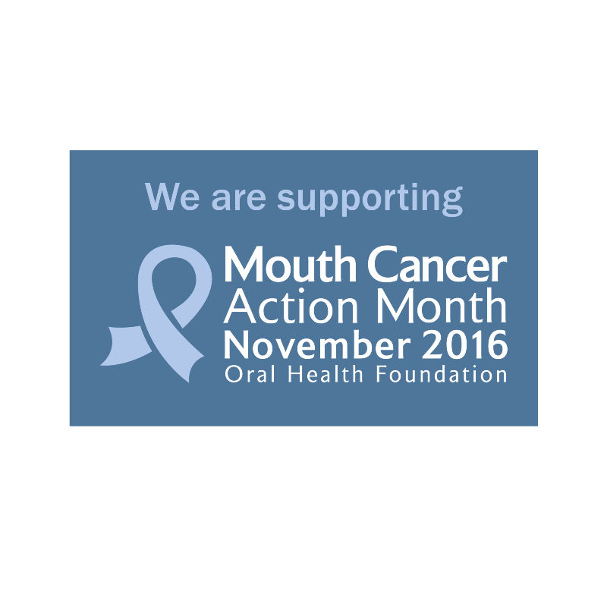**{INSERT YOUR COMPANY NAME}** | PRESS RELEASE

{YOUR COMPANY NAME} SET TO OFFER FREE MOUTH CANCER EXAMINATIONS

**To support November’s Mouth Cancer Action Month, {INSERT YOUR COMPANY NAME} will be offering free mouth cancer examinations to anybody in {INSERT TOWN/CITY/REGION} who would like one.**

The practice, based on **{INSERT ROAD/STREET}**, will be offering free oral health checks with mouth cancer examinations **{INSERT DATES E.G. throughout the month, between 1 – 7 November, on 26 November}**, in order to give back to their local community and make everyone in the area aware of mouth cancer and the importance of regular check-ups in protecting against this life-threatening disease.

**{INSERT LEAD STAFF MEMBER}** from **{INSERT YOUR COMPANY NAME}** said of the initiative: “Mouth cancer does not have the public awareness that other forms of cancer does, yet shockingly it claims more lives every year than testicular and cervical cancer combined. We need to change this.

“Through our initiative we want to spread awareness of mouth cancer, its causes, the signs and symptoms and the role your dentist can play in helping to catch the disease early enough to beat it.

“Simply register with the practice to receive your free examination which will last approximately 15 minute and checks the whole mouth including the cheeks, lips, tongue and gums.

Organised by the Oral Health Foundation, Mouth Cancer Action Month is aiming to reduce the amount of lives lost to mouth cancer by ensuring we are all aware of the symptoms and causes of the disease.

Chief Executive of the Oral Health Foundation, Dr Nigel Carter OBE added: “We are thankful for the support of **{INSERT YOUR COMPANY NAME}**. Mouth Cancer Action Month relies on the support of the dental industry and with their support we will save lives.

“Mouth cancer is one of the UK’s fastest increasing cancers, with cases up by almost 40 per cent in the last decade alone. Public awareness remains vital to combatting the disease and through us all being ‘mouthaware’ and spotting mouth cancer early enough, we are giving everyone the best possible chance to be successfully treated and have a good quality of life.

“I would advise everybody in the local area to take **{INSERT YOUR COMPANY NAME}** up on this opportunity. Survival rates for those with mouth cancer have not improved in the last 20 years and examination initiatives like this can make a real difference.”

Last year in the UK, more than 7,500 people were diagnosed with mouth cancer. The disease claims more lives than cervical and testicular cancer combined.

Look out for mouth ulcers which do not heal within three weeks, red and white patches in the mouth, and unusual lumps or swellings. If you notice any of these, please make an appointment you’re your dentist as soon as possible.

To book your free mouth cancer check contact the clinic directly on **{INSERT YOUR COMPANY TELEPHONE NUMBER}** or visit **{INSERT YOUR COMPANY WEBSITE}**.

**To find out more information about mouth cancer and Mouth Cancer Action Month, please visit** [**www.mouthcancer.org**](http://www.mouthcancer.org)

**- - - ENDS - - -**

**ABOUT MOUTH CANCER ACTION MONTH**

Every November, the Oral Health Foundation organises and runs Mouth Cancer Action Month, under the message ‘if in doubt, get checked out’. Our campaign has become an influential springboard in educating the public about mouth cancer, highlighting the risks, symptoms and causes of the disease.

The campaign is about taking action and raising awareness, particularly among those groups who are most at risk. We want people to look out for ulcers which do not heal within three weeks, red and white patches in the mouth, and unusual lumps or swellings while encouraging them to regularly visit a dentist to ensure they’re checked for signs of mouth cancer.

By working closely with the dental and health profession and supporting them in their activities to patients and local communities, we continue to increase mouth cancer awareness and save lives through early detection.

Mouth Cancer Action Month is Sponsored by Simplyhealth Professionals and is also supported by Dentists’ Provident.

For further information, please register your details at [www.mouthcancer.org](http://www.mouthcancer.org).